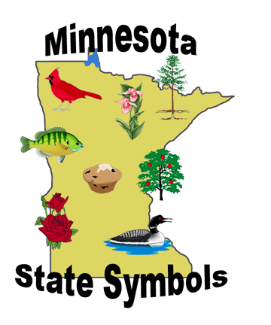
6th grade
Minnesota Studies

Ms. Zimowicz 763-506-4850 sara.zimowicz@anoka.k12.mn.us
Mr. Chasteen 763-506-4852 john.chasteen@anoka.k12.mn.us
Mr. Griffith 763-506-4868 todd.griffith@anoka.k12.mn.us

Minnesota Studies will examine Minnesota’s history, geography and government. We will start our year learning about the Ojibwe and Dakota civilizations and finish the year looking at Minnesota today. In between, we will hear about Minnesota’s statehood, involvement in the American Civil War, immigration and fun facts!

Goals of 6th grade Minnesota Studies
- I can describe the government of Minnesota.
- I can describe the geography of Minnesota.
- I can describe life in Minnesota throughout history.
- I can use a variety of maps to find information.

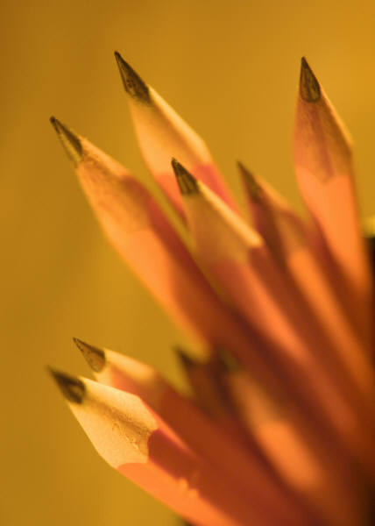
Expectations for Students:
- Materials Needed: 3 ring binder with loose leaf paper (or notebook and folder), pencils, and colored pencils.
- Behavior: Be respectful at all times to everyone and everything.
- Actively participate in class without disruptions.
- Follow directions the first time they are given.
        - Be on time to class with your materials.

- Participation: Students will be encouraged to participate in class discussions, debates, simulations, small groups and other activities.

- Homework: Time will be allotted during class for assignments. If the assignment is not completed during class time, then the assignment becomes homework.

- Large Projects: There will be ample amounts of class time available to complete any projects.

- Late Work: Students need to have all work turned in prior to taking unit tests. Late work will be accepted for full credit. Students can use Falcon CORE to complete missing work.

- When to Talk to the Teacher: When questions arise, please see the teacher immediately!

- Communication: The best way to reach me is via email. I will also hold office hours on the first Monday of each month from 7am – 7:40.

- Interventions: Students have multiple opportunities to get assistance during the school day. Students may utilize their Falcon CORE time or make special arrangements with me.

Grading

Grades are compiled based on 3 pieces of information:
- 70%: Assessments
- 10%: District Trimester Test
- 20%: Learning activities

There are few important details about grades:
- Students need to have ALL their work turned in before taking the unit summative assessment.
- Students will have the opportunity to turn in late work for full credit and to retake summative assessments if they score less than 70%.
- Students who earn less than 70% are encouraged to come in before school, during Falcon CORE, or stay afterschool.

To Parents and Guardians:

Welcome! We look forward to getting to know you and your student during the year!

Sixth grade is a year of great changes for your student- socially, emotionally, and academically. At school, we will do our best to aid your student as they undergo these many changes. Your student will be challenged in the following areas this year:

- Academics: Classes are more challenging than elementary school. We want to prepare your student for future classes at CRMS, in high school and beyond!

- Peer Relationships: 6th graders have an increased desire to fit in with their peers. We want students to feel confident, to respect others and to feel comfortable talking to all their classmates.

- Organization: using the Planner, scheduling extra work time when needed, taking materials to and from classes and keeping their locker clean and organized are just a few of the new challenges your student will face this year.

We believe your student can be successful this school year if the school and your family work together for the student's success. Please feel free to contact me at any time if you have a question or are concerned about your student's performance.

6th grade Minnesota Studies has a website with current study guides, assessment dates and links to helpful websites. You can navigate to it from the CRMS homepage (Academics ⇒ Classroom Pages ⇒ CRMS Social Studies ⇒ 6 Minnesota Studies ) or use the following address:

http://anokahennepin.schoolwires.net/Page/24769

Thank you,

Sara Zimowicz Todd Griffith John Chasteen
Sara.zimowicz@anoka.k12.mn.us Todd.griffith@anoka.k12.mn.us John.chasteen@anoka.k12.mn.us

